**Step 1:** <https://www.postgresql.org/download/>

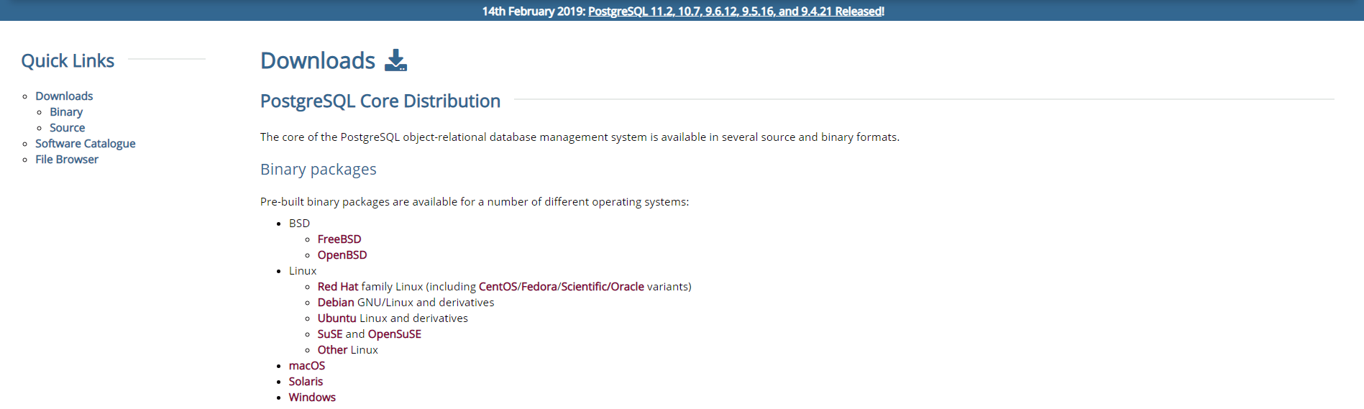

**Step 2:** Click the Hyperlink “Download the Installer”

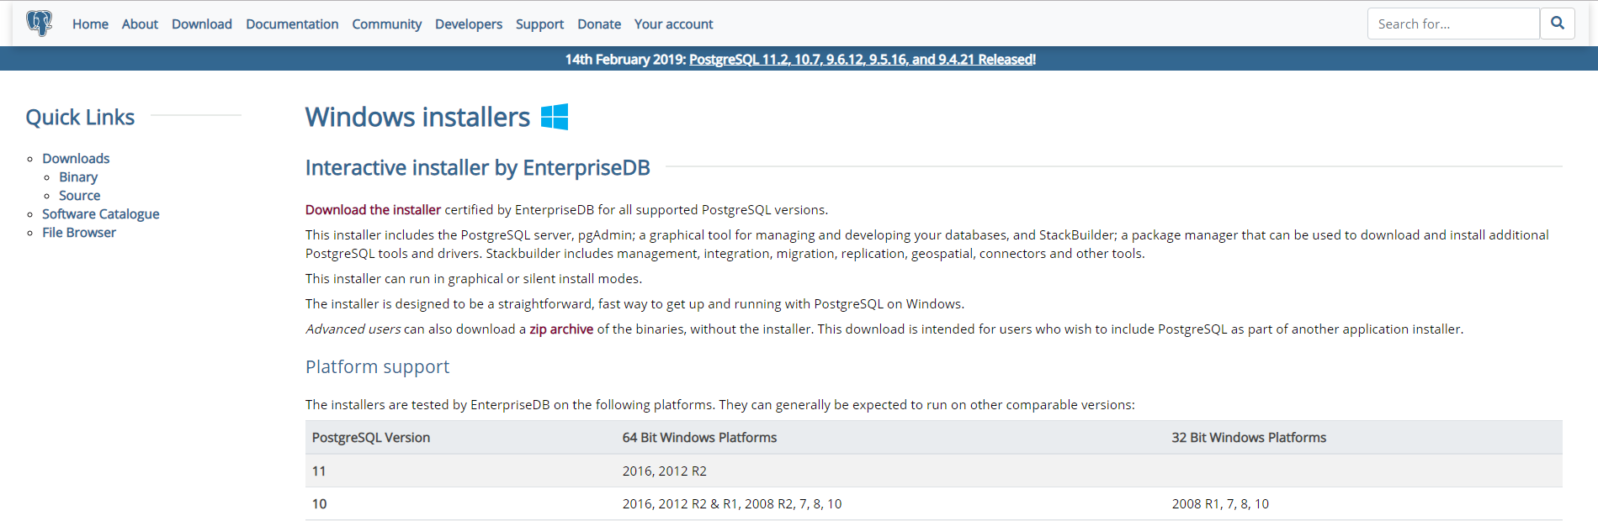

**Step 3:** Select the desired package for the installer

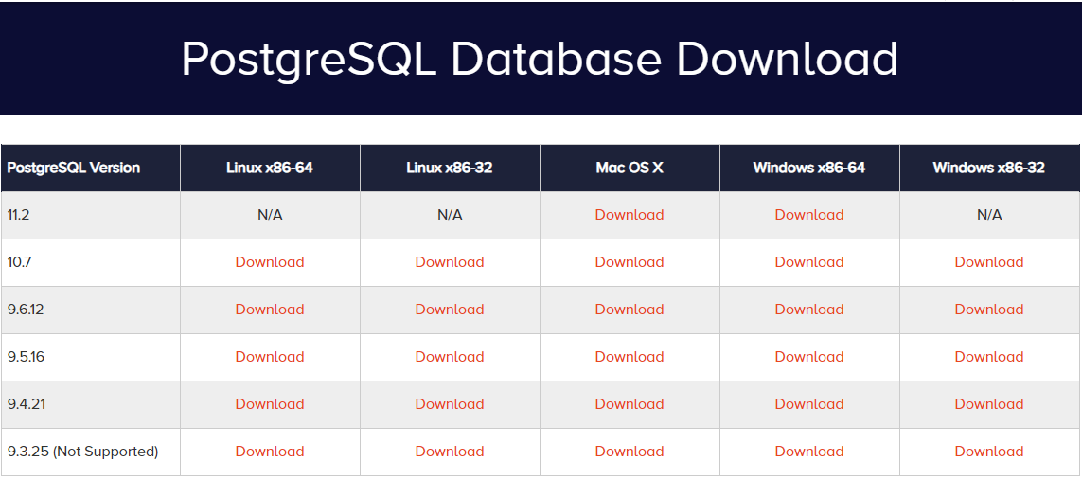

**Step 4:** Start the executable “postgresql-11.2-1-windows-x64”

**Step 5:** Proceed with the following highlighted steps,

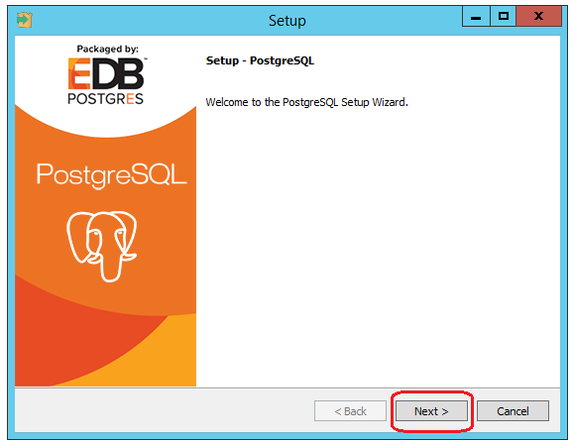

Select the destination folder and proceed next,

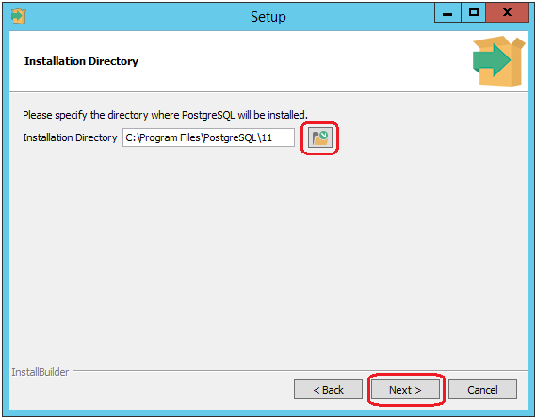

Select the components to be installed,

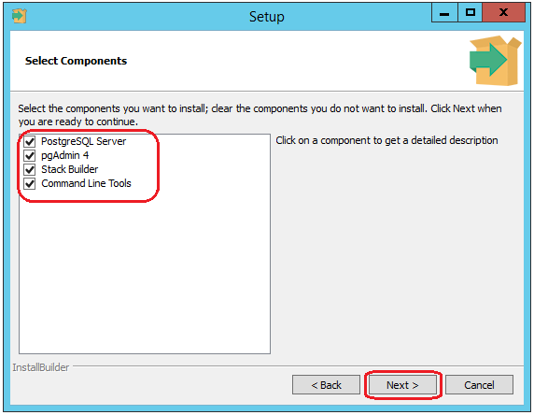

Select the Data directory and proceed next,

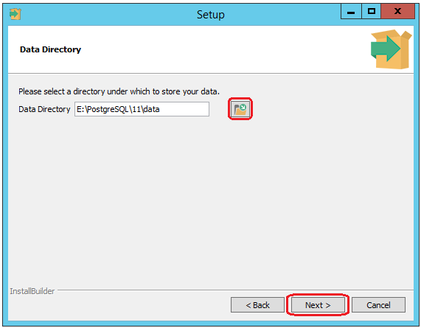

Enter the Super User password and proceed with next steps,

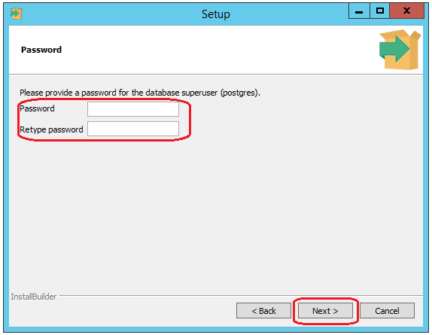

Set the port number for the server to listen on and proceed with the next step

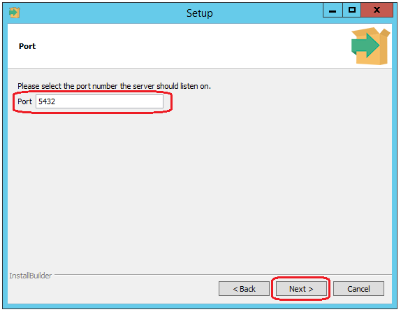

Define the locale for the Database and proceed with the next step,

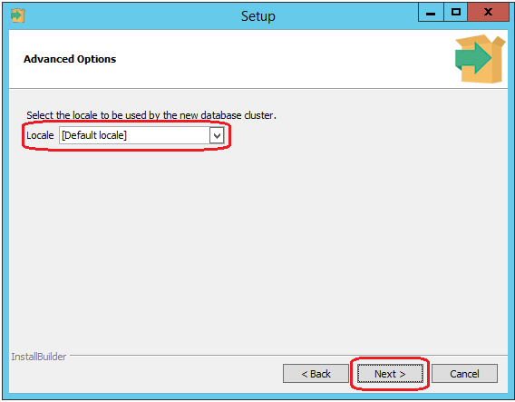

Review the pre-installation summary and proceed with the next step,

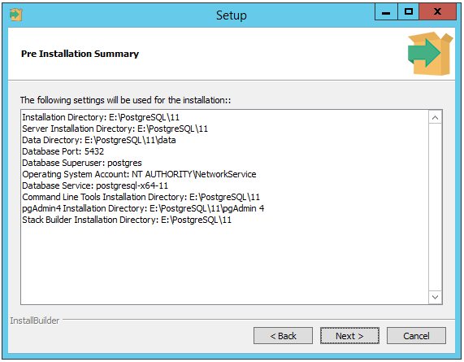

**Step 6:** After the Database installation execute the “pgadmin” utility,

..PostgreSQL\11\pgAdmin 4\bin\pgAdmin4.exe

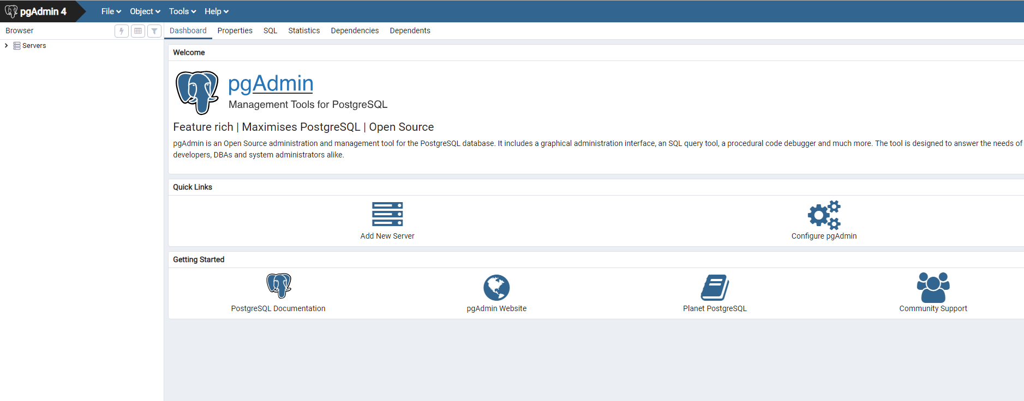

**Step 7:** By default PostgreSQL Database server would be up and running.

We’ll create a separate server for the Exstream Database,

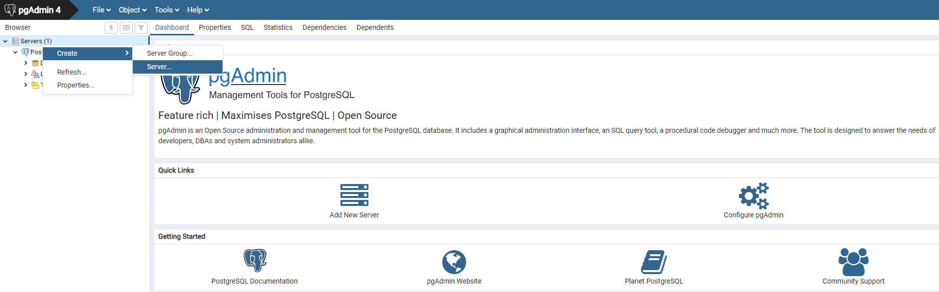

**Step 8:**

Set server name in the General tab

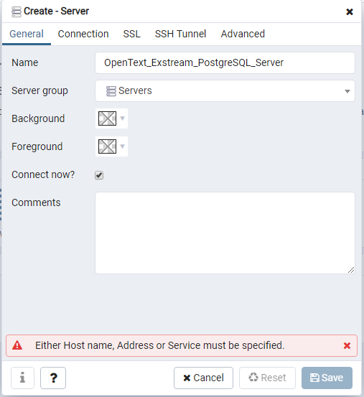

Set the host details and DB User name, password and Save

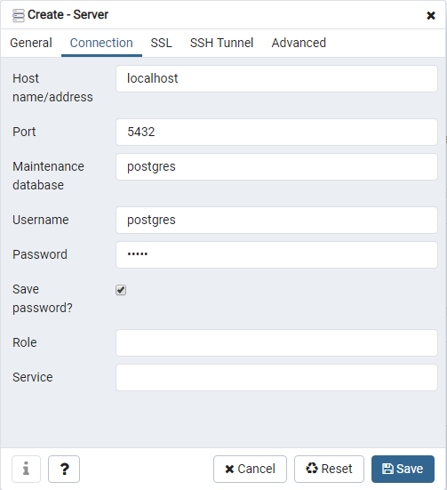

**Step 9:** Inside the server create the Database for Exstream,

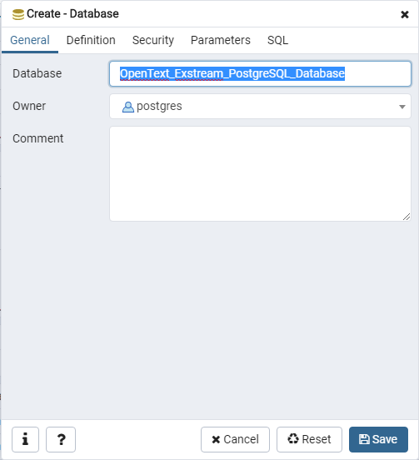

**Step 10:** Set the server up and running

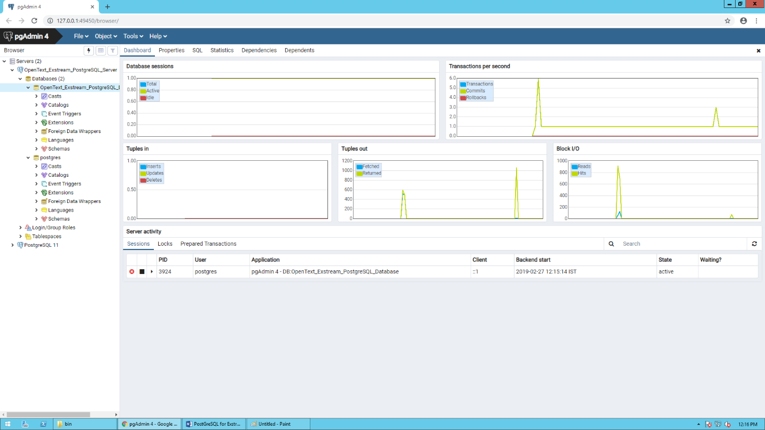

**ODBC Connectivity for local client**

**Install the PostgreSQL ODBC driver in the EC2 instance.**

ODBC Driver Location

<https://www.postgresql.org/ftp/odbc/versions/msi/>

psqlodbc_10_01_0000-x64.zip

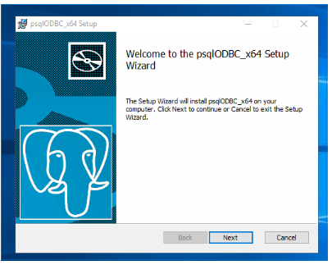

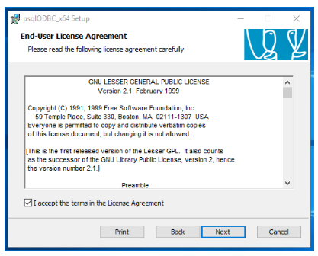

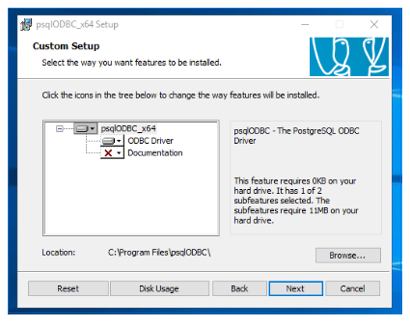

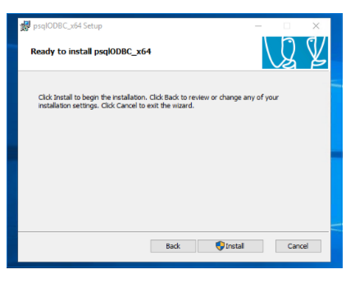

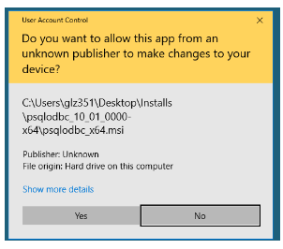

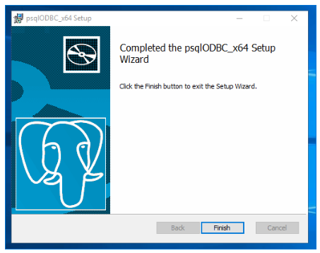

Once ODBC driver install is complete it will show corresponding updates in ODBC managers in control panel.

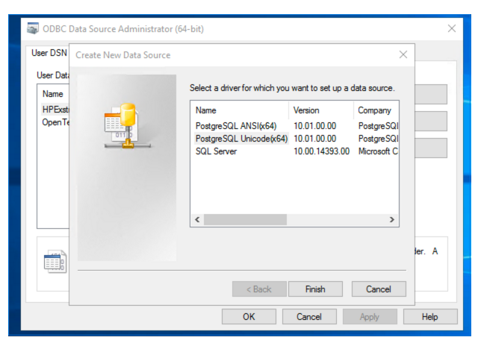

Depending on the engine setup we should choose the correct ODBC driver.

This is the recommendations from OpenText:

The PostgreSQL ODBC Driver is available as both a Unicode driver and an ANSI driver. When you create the DSNs for your design and tracking databases, you must select the appropriate driver for your engine:

* Use the PostgreSQL Unicode driver when you create DSNs for use with the Design and Production design tools (Design Manager, Designer, and Logic Designer) and the DBCS engine.
* Use the PostgreSQL ANSI driver when you create DSNs for use with the SBCS engine.

**Create DSN to new PostgreSQL database.**

Step #6

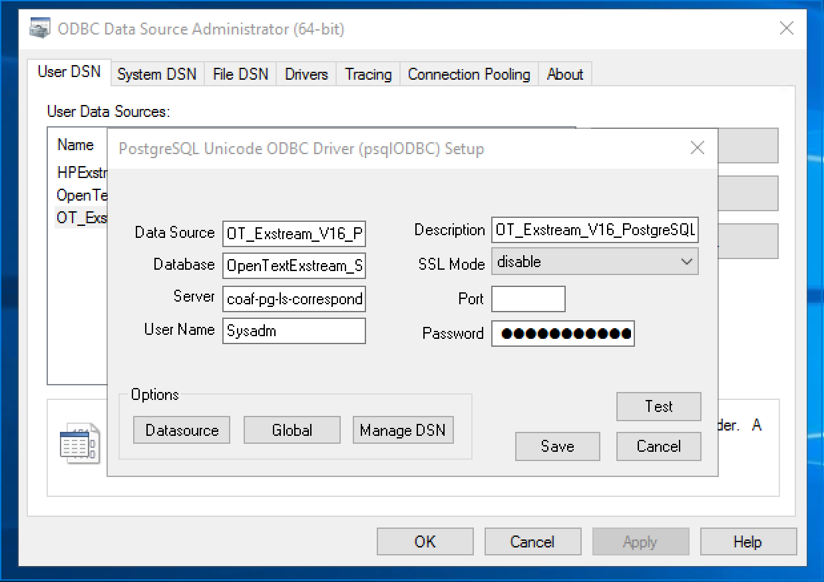

Use AWS CName for the server name to avoid IP issues.

Creating DB structure for new PostgreSQL database.

Open DBAdmin_dbcs.exe or DBAdmin.exe based on engine setup.

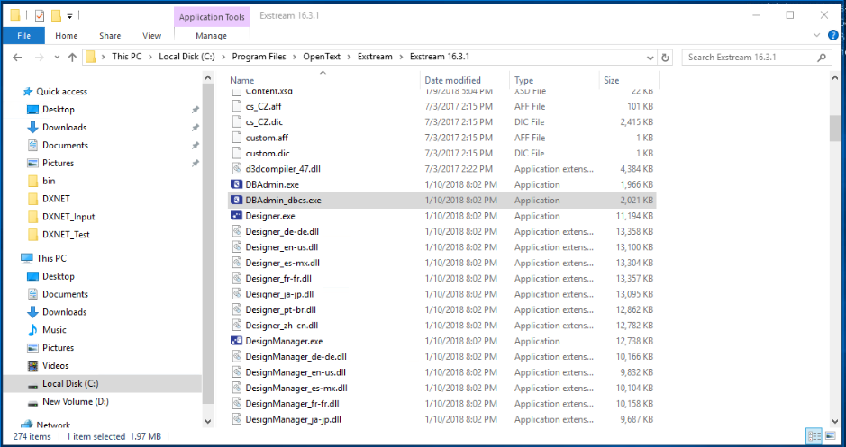

Connect to new PostgreSQL database using DSN created in Step #6.

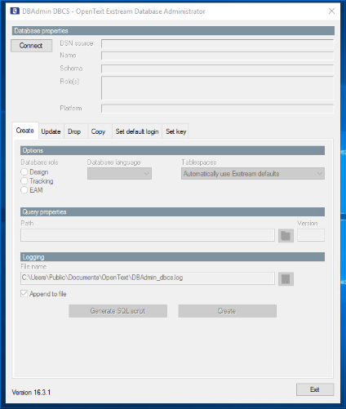

Once connected it will show all the DSN setups.

In the create tab make sure the Design, Language and Log paths.

Once ready click “Create” button.

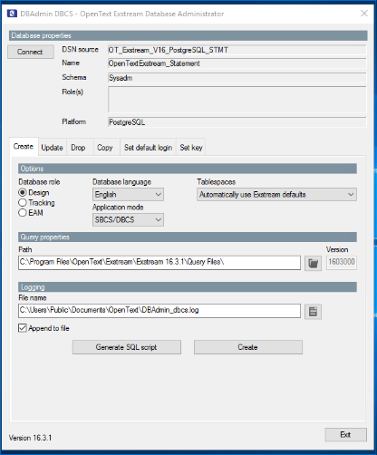

This will ask permission to grand access for tables created.

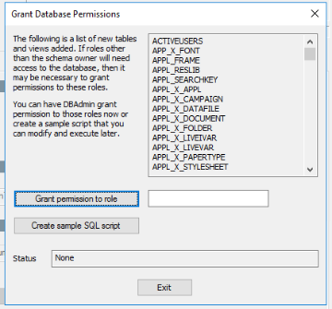

Once success it will display the following message.

